KINOTI MARTIN MWENDA
BSCCS/2024/32193
COMPUTER SCIENCE
BIT4133
NATURAL LANGUAGE PROCESSING WITH DEEP LEARNING
MICHAEL NYORO
YEAR IV, SEMESTER II

PROJECT:
AI CHATBOT: https://github.com/martin-m-kinoti/ai-chatbot

TECHNOLOGIES USED:
PYTHON
NLTK
JUPYTER NOTEBOOK

NLP TASKS REPO
https://github.com/martin-m-kinoti/nlp-tasks

Table of Content
WEEK 1: INTRODUCTION TO NLP CONCEPTS AND TEXT PROCESSING 1
1.1 Packages Installation 1
1.2 Jupyter Notebook Setup 1
1.3 NLTK Installation 2
1.4 Tokenization Output 2
1.5 Stopwords Removal 3
1.6 NLP Application 4
WEEK 2: LANGUAGE MODELING AND SENTENCE STRUCTURE ANALYSIS 5
2.1 N-gram Output 5
2.1.1 Bi-gram 5
2.1.2 Tri-gram 5
2.1.3 N-gram: 10-gram 6
2.2 POS Tagging Example 6
2.3 Python Code for POS Tagging 7
2.4 Language Prediction Example 7
2.5 Sentence Analysis Output 8
WEEK 3: SEQUENCE PREDICTION AND HIDDEN STATE ANALYSIS 9
3.1 Sequence Labeling Code 9
3.2 Hidden Markov Model Output 9
3.3 Named Entity Recognition Example 10
3. 4 Sentence Labelling Results 10
3.5 Dataset Used for Training or Testing 11
WEEK 4: SYNTACTIC AND SEMANTIC ANALYSIS 12
4.1 Practical Tasks 12
4.1.1 Dependency Parsing using SpaCy 12
4.1.2 Semantic Similarity Analysis 12
4.2 Assignments 13
4.2.1 Dependency Structure Analysis 13
4.2.2 Semantic Similarity Comparisons 14
4.2.1.1 Similar Statements 14
4.2.1.2 Unrelated Statements 14
WEEK 5: MINI-NLP PROJECTS 16
5.1 Tasks 16
5.1.1 Complete NLP Pipeline 16
5.1.2 Mini-Chatbot Simulation 16
5.2 Mini-Project: Student Academic Assistant Chatbot 17

List of Figures
Fig 1. 1 Python packages installation 1
Fig 1. 2 Jupyter notebook setup 1
Fig 1. 3 NLTK installation on notebook 2
Fig 1. 4 Text Tokenization 2
Fig 1. 5 Stop words removal 3
Fig 1. 6 NLP application research 4

Fig 2. 1 Bi-gram output 5
Fig 2. 2 Tri-gram output 5
Fig 2. 3 N-gram (10-gram) output 6
Fig 2. 4 POS (Part-of-Speech) tagging output 6
Fig 2. 5 POS (Part-of-Speech) tagging Python code 7
Fig 2. 6 Language prediction using bigrams 7
Fig 2. 7 Sentence analysis output: tokenization, POS tags, and NER 8

Fig 3. 1 Sequence labeling code and output 9
Fig 3. 2 HMM (Hidden Markov Model) structure output 9
Fig 3. 3 NER (Named Entity Recognition) code and output 10
Fig 3. 4 Sentence labeling for sentiment analysis using MultinomialNB model 10
Fig 3. 5 Movie Reviews dataset used in training and testing the model 11

Fig. 4. 1 Dependency parsing using the SpaCy library 12
Fig. 4. 2 Semantic similarity analysis between two statements 12
Fig. 4. 3 Dependency analysis on text using SpaCy 13
Fig. 4. 4 Dependency analysis using OpenAI API 13
Fig. 4. 5 Semantic similarity comparison between similar statements 14
Fig. 4. 6 OpenAI semantic similarity comparison between similar statements 14
Fig. 4. 7 Semantic similarity comparison between unrelated statements 14
Fig. 4. 8 OpenAI semantic similarity comparison between unrelated statements 15

Fig. 5. 1 Complete NLP process 16
Fig. 5. 2 Mini chatbot simulation 16
Fig. 5. 3 OpenAI student academic assistant mini chatbot 17

WEEK 1: INTRODUCTION TO NLP CONCEPTS AND TEXT PROCESSING

1.1 Packages Installation
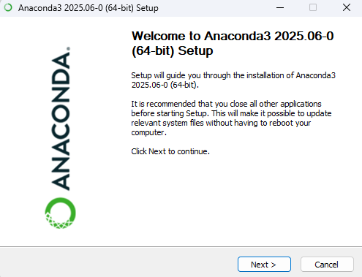
Fig 1. 1 Python packages installation
Fig. 1.1 above shows the process of installing Anaconda, a Python library used for data analysis. The library comprises multiple libraries used in the Python coding environment, once installation is completed.

1.2 Jupyter Notebook Setup
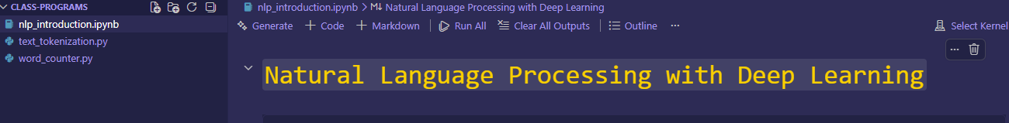
Fig 1. 2 Jupyter notebook setup
Fig. 1 .2 shows a notebook setup in VS Code. The notebook is then connected to the installed Anaconda packages to run the code throughout the notebook.

1.3 NLTK Installation
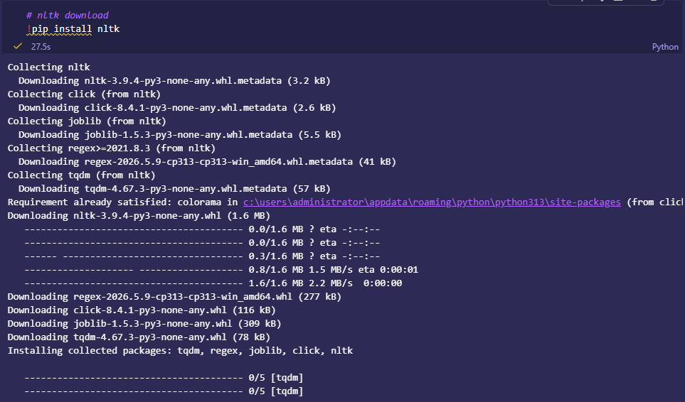
Fig 1. 3 NLTK installation on notebook
Fig 1.3 above shows the installation of NLTK (Natural Language Tool Kit), which is used for NLP tasks. Installation is required before using it in the development environment.

1.4 Tokenization Output
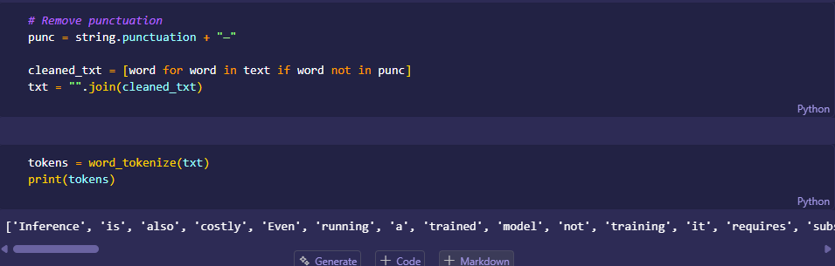
Fig 1. 4 Text Tokenization
Fig 1.4 shows the first step involved in NLP tasks, that is, tokenization. Tokenization is the process of breaking a sentence into individual words. Punctuations can also be removed, to ensure they are not treated as words.

1.5 Stopwords Removal
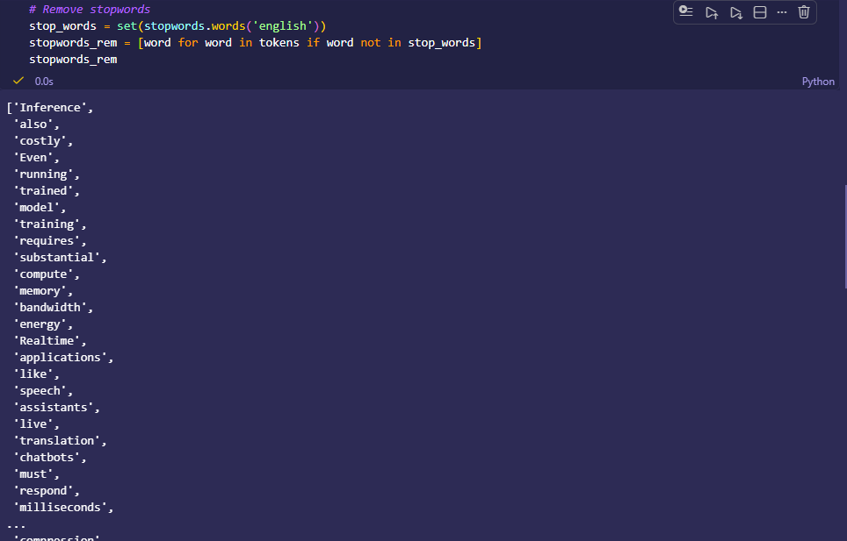
Fig 1. 5 Stop words removal
Fig 1.5 shows the next step of NLP. Stopwords are removed from the text tokens, to remain with the context-relevant words only. This eliminates noise and the use of words that bring meaning only.

1.6 NLP Application
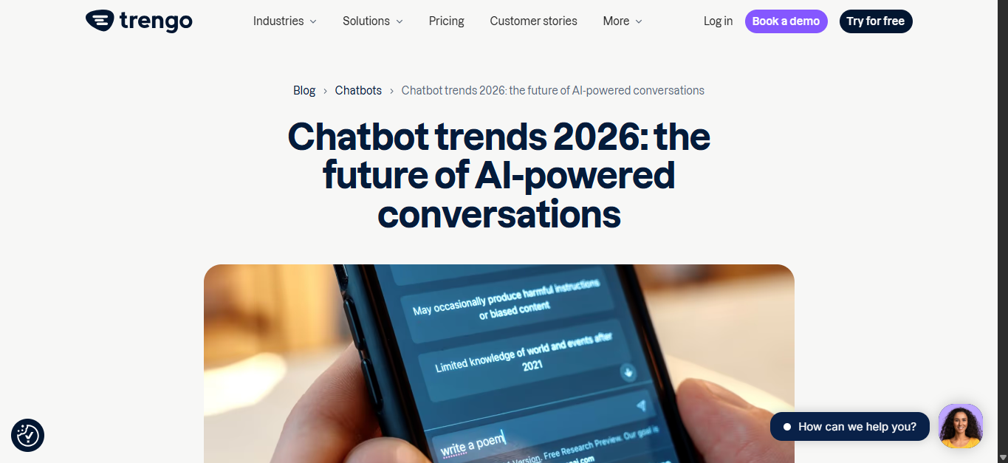
Fig 1. 6 NLP application in chatbots
Fig. 1.6 above shows an article on the various current chatbot trends. Chatbot development has evolved from classical rule-based systems to AI-powered tools that can understand meaning, context, and intent. AI chatbots are driven by NLP, machine learning, and generative AI.

WEEK 2: LANGUAGE MODELING AND SENTENCE STRUCTURE ANALYSIS

2.1 N-gram Output

2.1.1 Bi-gram
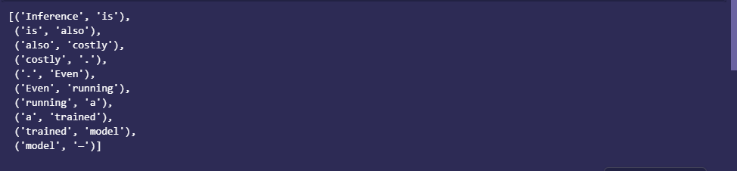
Fig 2. 1 Bi-gram output
Fig 2.1 shows a bi-gram, which is a sequence of two words extracted from a given text.

2.1.2 Tri-gram
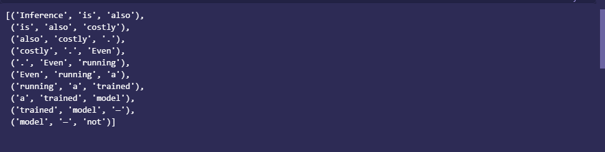
Fig 2. 2 Tri-gram output
Fig 2.2 above shows a tri-gram. These are sets of three words extracted from tokens belonging to a particular text.

2.1.3 N-gram: 10-gram
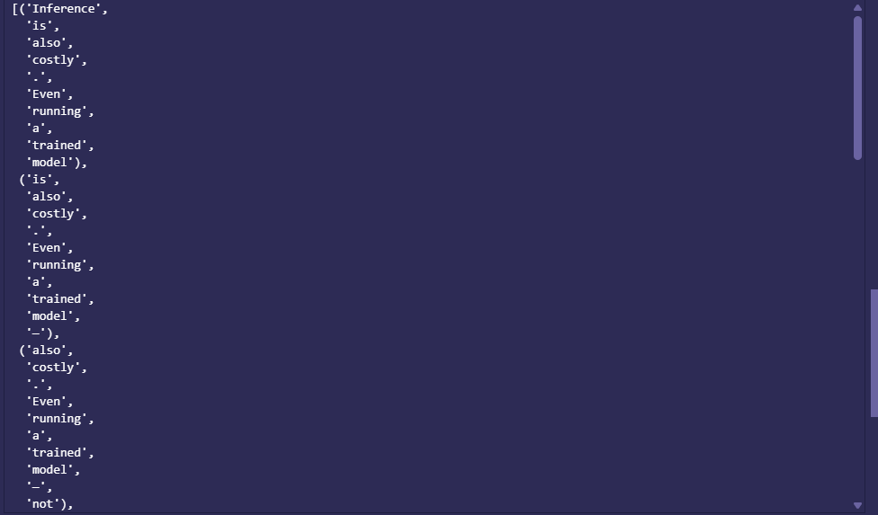
Fig 2. 3 N-gram (10-gram) output
Fig 2.3 shows an n-gram. It contains sets of 10 tokens from the text. N-grams can be of any number, where the number of tokens in a set is set using the n parameter..

2.2 POS Tagging Example
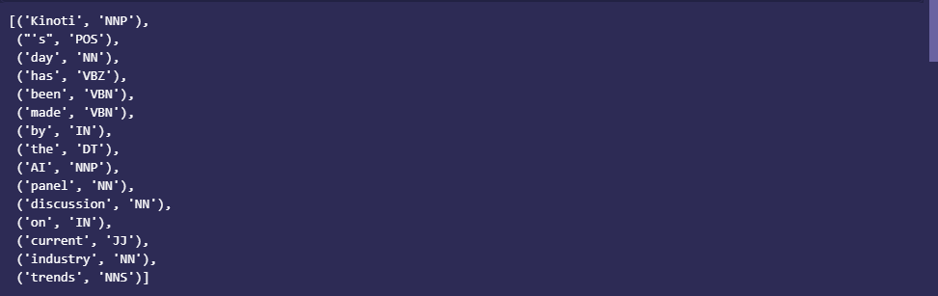
Fig 2. 4 POS (Part-of-Speech) tagging output
Fig 2.4 shows a POS tagging output. The sentences are divided into tokens, and each is assigned its grammatical representation, such as a noun (NN) and a verb (VBZ)

2.3 Python Code for POS Tagging
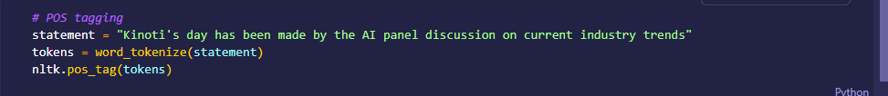
Fig 2. 5 POS (Part-of-Speech) tagging Python code
Fig 2.5 above shows a Python code used to perform POS tagging. This is done using NLTK library. The output of this code is shown in Fig 2.4 above.

2.4 Language Prediction Example
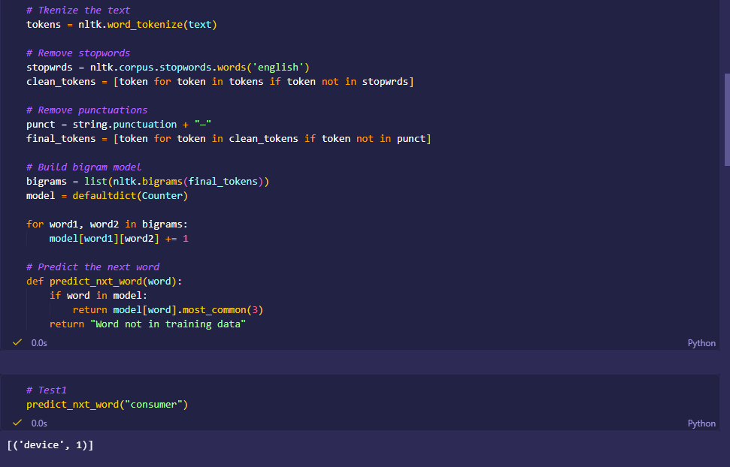
Fig 2. 6 Language prediction using bigrams
Fig 2.6 shows the process used in predicting language using n-grams. The text is first tokenized, punctuation and stop words removed, and the bigrams created from the text. These bigrams are used to determine the sequence of words, hence used in predicting the next possible word based on probability.

2.5 Sentence Analysis Output
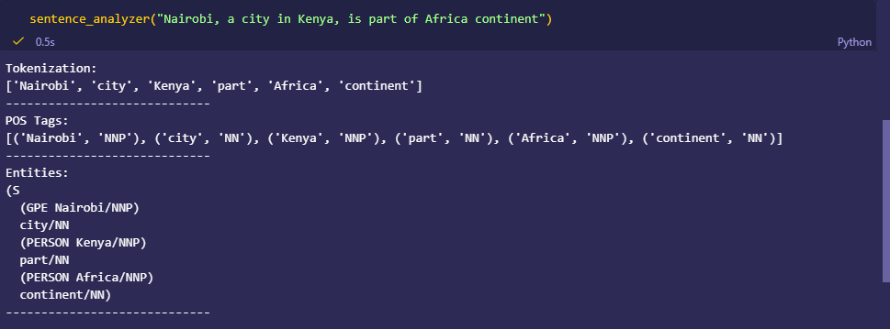
Fig 2. 7 Sentence analysis output: tokenization, POS tags, and NER
Fig 2.7 shows a sentence analysis output, a result of the sentence analysis pipeline. The pipeline follows: tokenization, POS tagging, and lastly NER. This process performs a full sentence analysis.

WEEK 3: SEQUENCE PREDICTION AND HIDDEN STATE ANALYSIS

3.1 Sequence Labeling Code
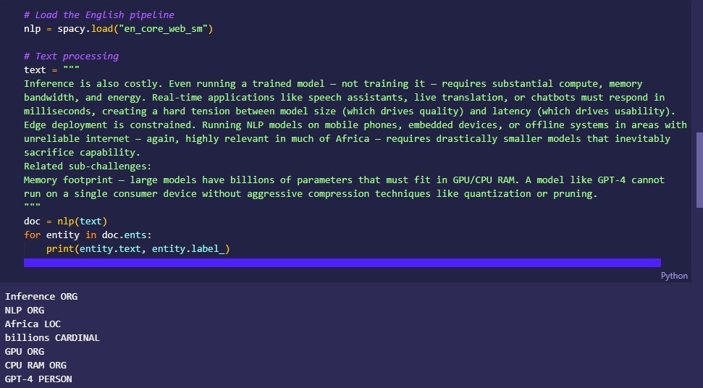
Fig 3. 1 Sequence labeling code and output
Fig. 3.1 above shows a Python sequence labeling code using SpaCy. The tokens of the text are labeled using POS and NER.

3.2 Hidden Markov Model Output
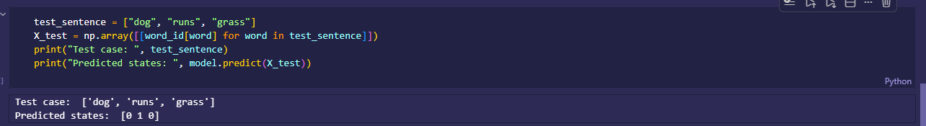
Fig 3. 2 HMM (Hidden Markov Model) structure output
Fig. 3 .2 above shows the functionality of HMM and how it performs sequence labeling. From the figure, the HMM model learns from the data provided during training by capturing the hidden state information. The testing statement is then processed by the model, which predicts the hidden states of the words, and produces the sequence in which they exist.

3.3 Named Entity Recognition Example
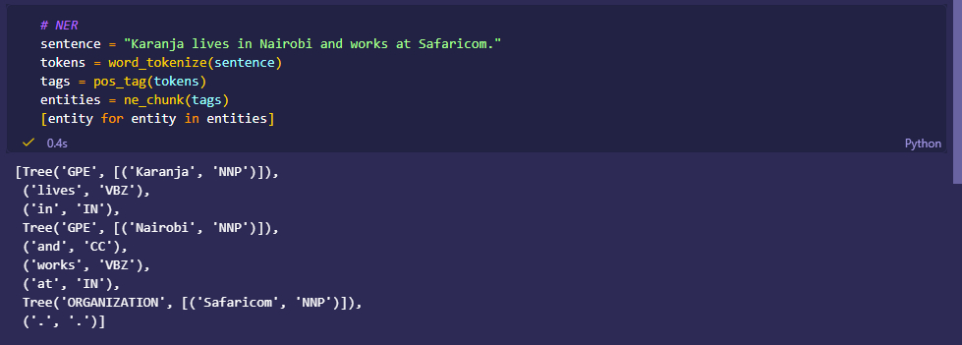
Fig 3. 3 NER (Named Entity Recognition) code and output
Fig. 3.3 shows an example of NER (Named Entity Recognition) as is applied in sequence labeling. The statement is first tokenized using NLTK’s word_torkenize, then tagged using POS, and then NER is performed. The entities are identified and labeled accordingly, such as the label “ORGANIZATION” assigned to Safaricom.

3. 4 Sentence Labelling Results
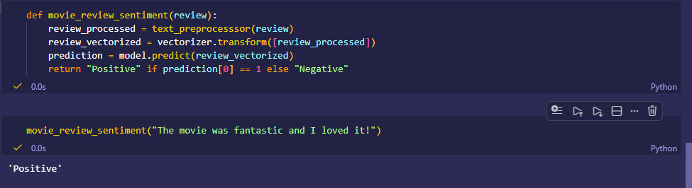
Fig 3. 4 Sentence labeling for sentiment analysis using MultinomialNB model
Fig 3.4 above shows sentence labeling using machine learning. The model MultinomialNB is trained, and tested on the data. Vectorization, and label encoding was done before model creation, to enable learning. The model is then used to predict the label for the given statement as either “Negative” or “Positive” classification.

3.5 Dataset Used for Training or Testing
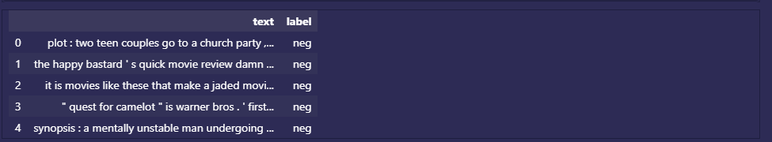
Fig 3. 5 Movie Reviews dataset used in training and testing the model
Fig. 3.5 shows the data that was used to train the sentence labeling MultinomialNB model in Fig. 3 .4 above. The NLTK data “movie_reviews” comprises two columns: the text and the associated labels. The data comprises 2000 records, equally balanced in labels. 80% of the data was used for training, and the rest was used for testing.

WEEK 4: SYNTACTIC AND SEMANTIC ANALYSIS

4.1 Practical Tasks

4.1.1 Dependency Parsing using SpaCy
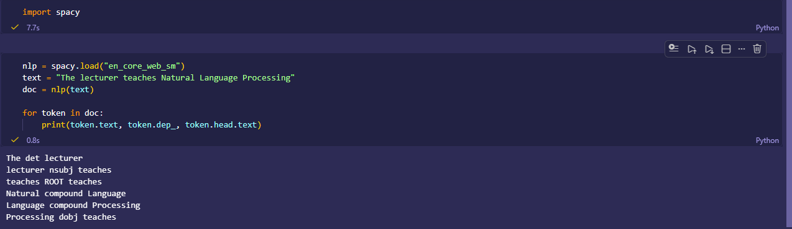
Fig. 4. 1 Dependency parsing using the SpaCy library
Fig.4.1 above shows dependency parsing using the SpaCy library. The text is analyzed by the library, which defines the grammatical structure of the sentence and how one word relates to the others.

4.1.2 Semantic Similarity Analysis
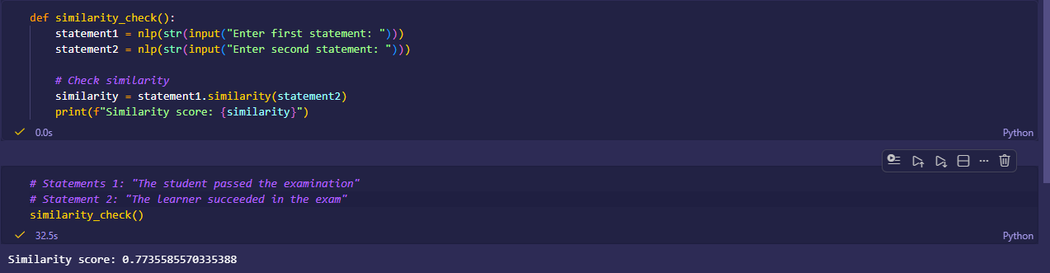
Fig. 4. 2 Semantic similarity analysis between two statements
Fig. 4.2 shows semantic similarity between two statements. The output shows that the degree of similarity is around 77%, which indicates that the two statements are highly similar.

4.2 Assignments

4.2.1 Dependency Structure Analysis
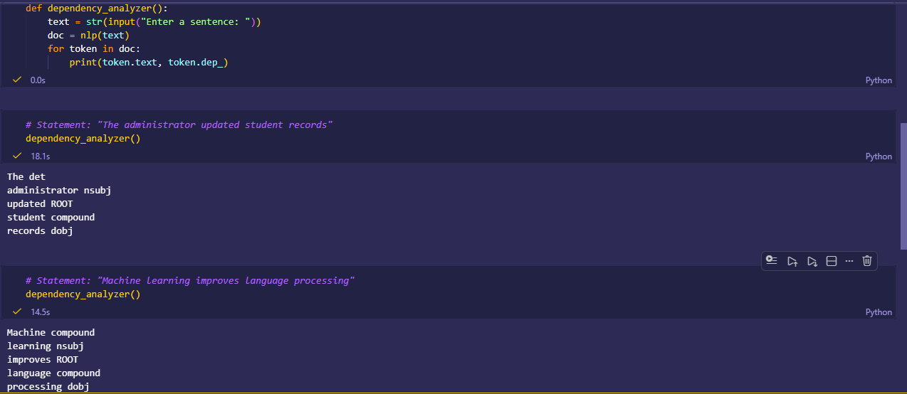
Fig. 4. 3 Dependency analysis on text using SpaCy
Fig. 4.3 shows dependency parsing in the statements. The statements are analyzed to show the grammatical structure, including POS tags on how each word is related to the next.
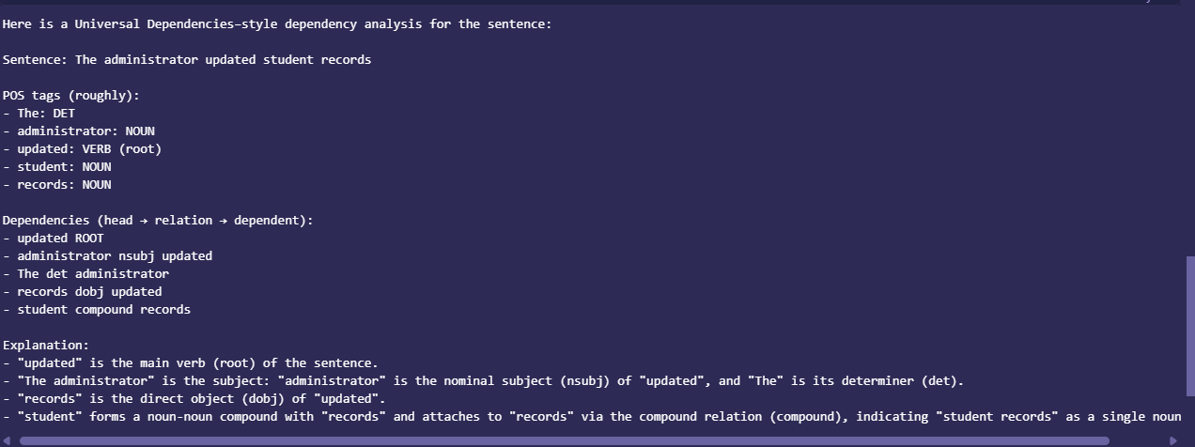
Fig. 4. 4 Dependency analysis using OpenAI API
Fig. 4.4 above shows dependency analysis using the OpenAI API. Similar to spaCy, but provides additional explanations on the grammatical structure of the sentence. This is done using prompt engineering, based on the requirements you need.

4.2.2 Semantic Similarity Comparisons

4.2.1.1 Similar Statements
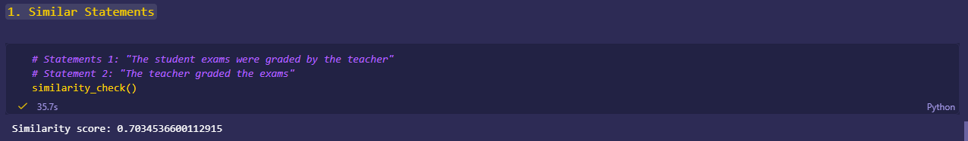
Fig. 4. 5 Semantic similarity comparison between similar statements
Fig. 4.5 above shows semantic similarity analysis of two statements, producing a similarity score of around 70%. This indicates that the two are highly similar.
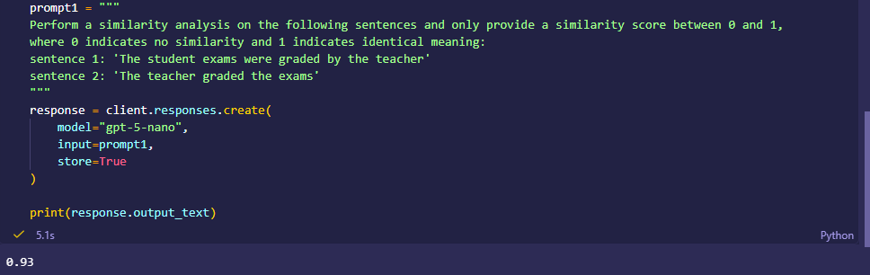
Fig. 4. 6 OpenAI semantic similarity comparison between similar statements
Fig. 4.6 shows the use of OpenAI API in semantic similarity comparison of related sentences. The two statements are highly similar, given a similarity score of 93%.

4.2.1.2 Unrelated Statements
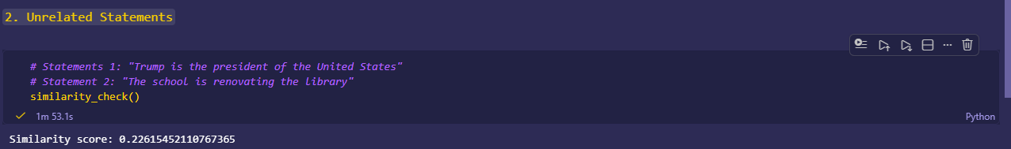
Fig. 4. 7 Semantic similarity comparison between unrelated statements
Fig 4.7 shows a semantic similarity comparison between similar statements using spaCy. The two statements are highly dissimilar, given a similarity score of around 23%.
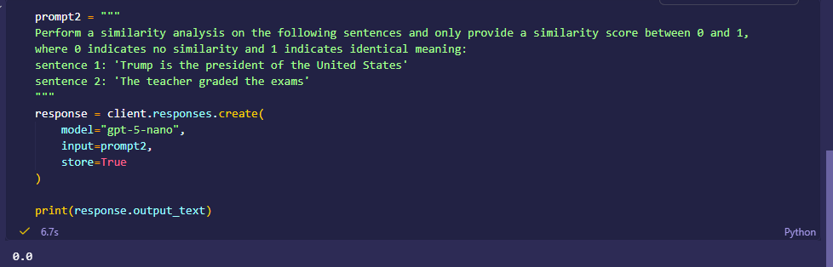
Fig. 4. 8 OpenAI semantic similarity comparison between unrelated statements
Fig. 4.8 shows semantic similarity using the OpenAI API. The similarity score of 0% indicates that the two statements are not similar.

WEEK 5: MINI-NLP PROJECTS

5.1 Tasks

5.1.1 Complete NLP Pipeline
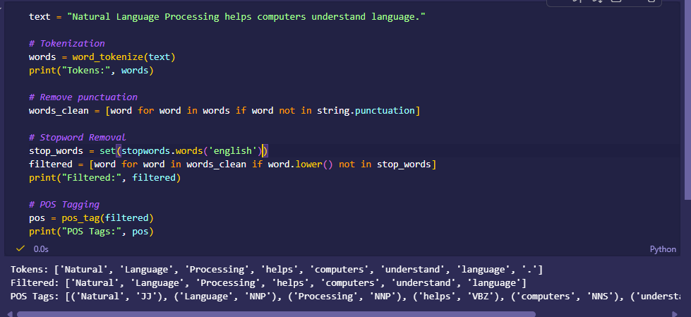
Fig. 5. 1 Complete NLP process
Fig. 5.1 above shows a complete NLP pipeline, comprising word tokenization, punctuation mark removal, stop words removal, and POS tagging. All these steps are shown in the outputs, indicating what action has been performed.

5.1.2 Mini-Chatbot Simulation
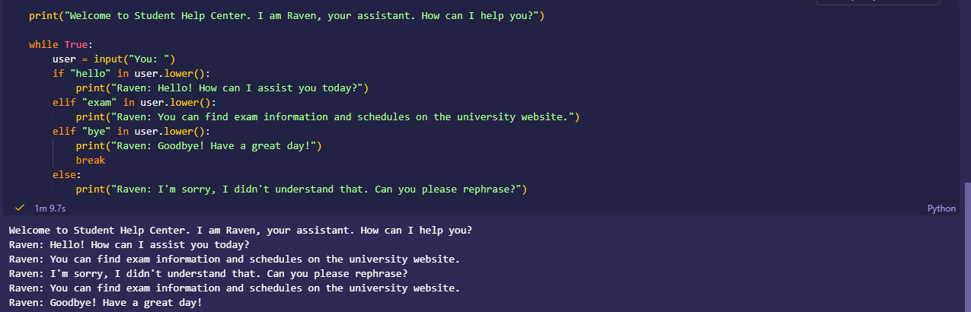
Fig. 5. 2 Mini chatbot simulation
Fig. 5.2 above shows a rule-based chatbot simulation. The chatbot identifies keywords in the user input and responds accordingly. This approach is classic, and the chatbot does not understand context, which means that the use of synonyms of the keywords would not be understood by the chatbot.

5.2 Mini-Project: Student Academic Assistant Chatbot
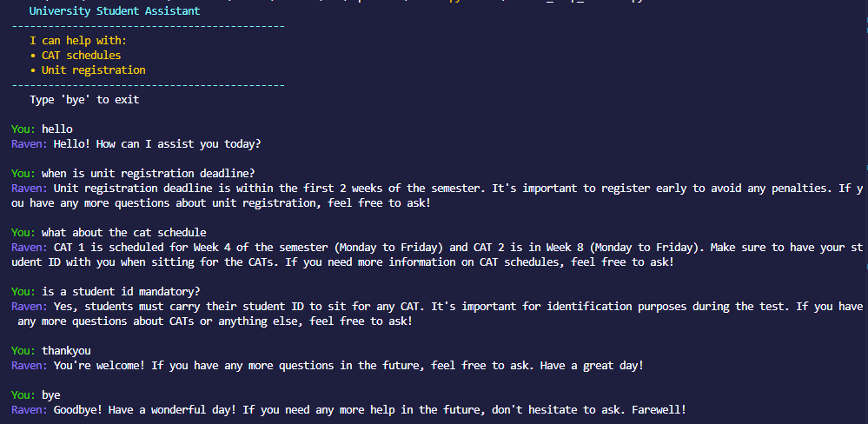
Fig. 5. 3 OpenAI student academic assistant mini chatbot
Fig. 5.3 shows a student academic assistant chatbot that uses the OpenAI API. The model is fed a prompt guiding it on how to response on the various actions, including greetings and academic queries. The chatbot understands the context and synonyms of words, which is better compared to the rule-based approach in Fig. 5.2 above.

